A Eureka Server is a service registry used in microservices architectures, particularly within the Spring Cloud ecosystem. It is part of the Netflix OSS suite, which has been integrated into Spring Cloud to facilitate service discovery. Here's a concise overview of what a Eureka Server does:

**What is a Eureka Server?**

1. **Service Registry**: The Eureka Server acts as a service registry where various microservices (clients) can register themselves at runtime.
2. **Service Discovery**: It allows microservices to discover each other. Microservices can query the Eureka Server to find other services and get information about their network locations (IP addresses and ports).
3. **Load Balancing and Failover**: With service discovery, clients can use this information to load balance and implement failover strategies, improving the resilience and scalability of the system.

**Setting Up a Eureka Server**

To set up a Eureka Server in a Spring Boot application, follow these steps:

**1. Add Dependencies**

Add the necessary dependencies to your **pom.xml** (for Maven):

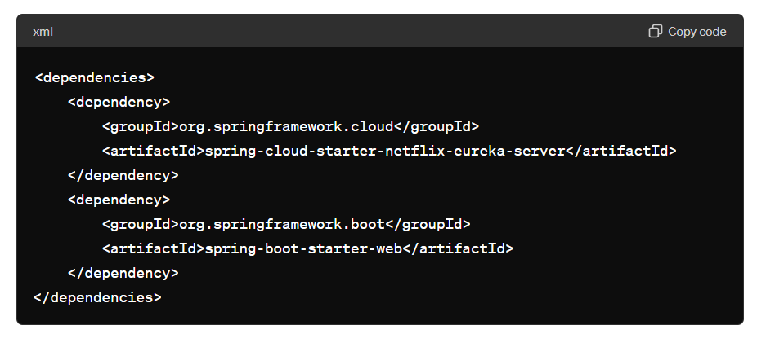

**2. Main Application Class**

Create the main application class and annotate it with **@EnableEurekaServer** to enable the Eureka Server functionality:

java

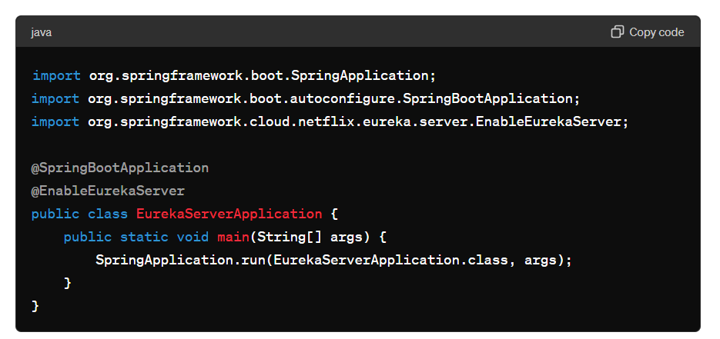

#### 3. Configuration

Create a configuration file **application.yml** or **application.properties** to set up the Eureka server configuration:

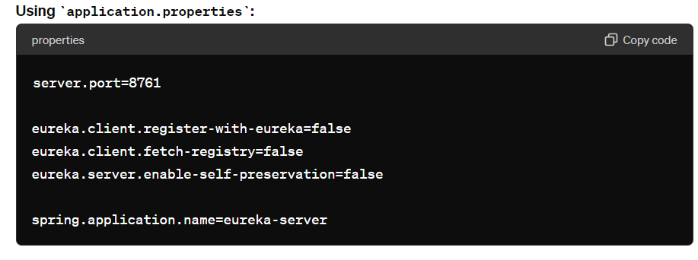

### Running the Eureka Server

Once you've added the dependencies, set up the main application class, and configured the properties, you can run the Eureka Server application. It will start on port 8761 (as specified) and will be accessible at **http://localhost:8761**.

### Integrating Eureka Clients

To register microservices as Eureka clients, add the following dependencies and annotations to your microservice applications:

#### Dependencies for Clients

Add the Eureka client dependency:

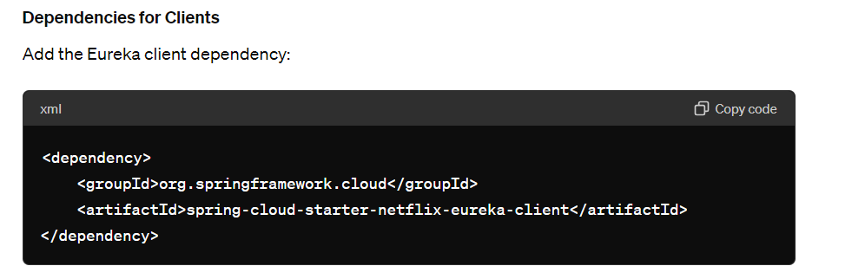

#### Enable Eureka Client

Annotate the main class of the microservice with **@EnableEurekaClient**:

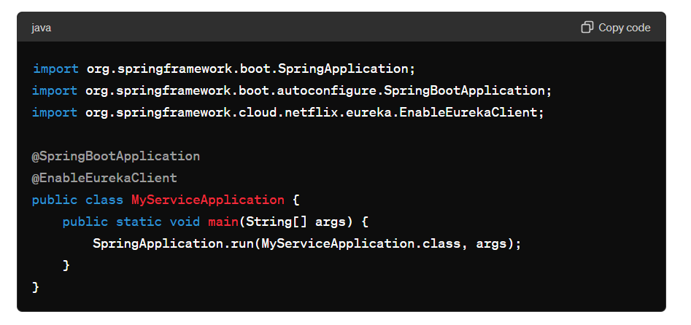

#### Configuration for Clients

Configure the Eureka client in **application.yml** or **application.properties**:

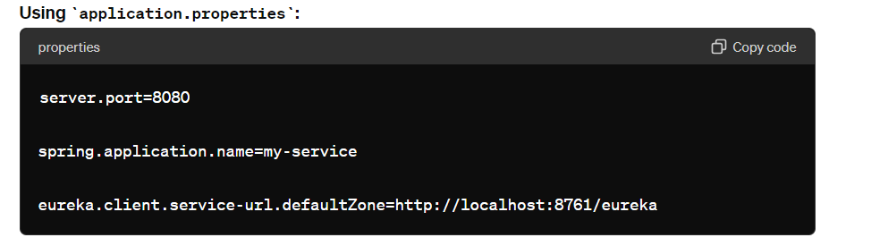

By following these steps, you can set up a Eureka Server for service registration and discovery, and configure your microservices to register with and discover each other through the Eureka Server.